Juniette Fiore, Nicole Andujar, and Izzy Geller

CIM413/613: Final Report

**GreenDaze**

**Description**

GreenDaze is an application to remind users to maintain their healthy habits to maintain a healthy earth. The motivation is to promote environmentally-friendly habits and show users that they can contribute to the well-being of the planet by upkeeping small changes to their routine.The target users are people who would like to improve their behaviors regarding environmental awareness.

**Human Interface Guidelines**

**(**a brief description about how the design follows the iOS Human Interface Guidelines)

For the Human Interface Guidelines, we are including some **Controls** such as:

Buttons, switches, text fields, and progress indicators

Another thing we are including are **Bars** which will tell people where they are in the navigation of the app. Some pages will contain images as buttons (Recycle, Reuse, Transportation, and Water Usage) and they will initiate the action to go to the next page.

We are also including several navigation **Views.** These views contain the primary content people see in the app, such as text, graphics, animations, and interactive elements. Some views in the Greed Daze app will enable behaviors such as scrolling, insertion of information, with Labels, Drop Down Menu, and Selection.

Alerts will also be included to notify the user when they have saved their notification settings to track the progress of their new desired behavior in any and all of the sections of the app.

**Screenshots**

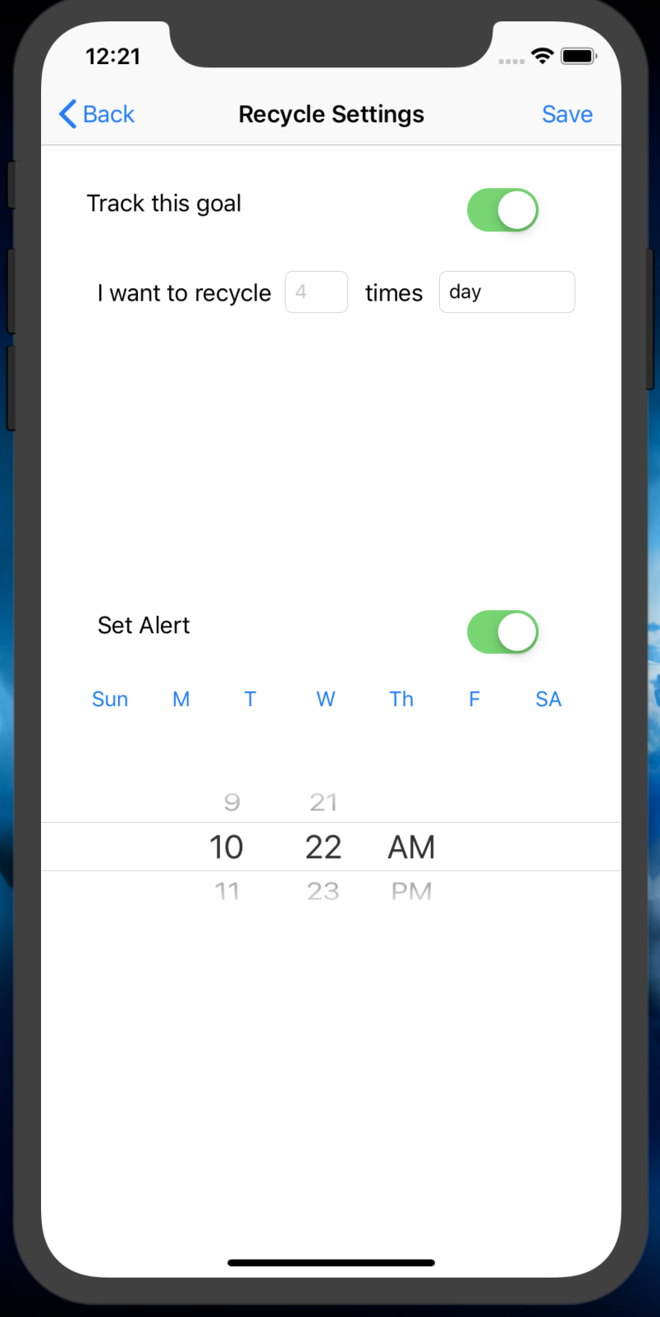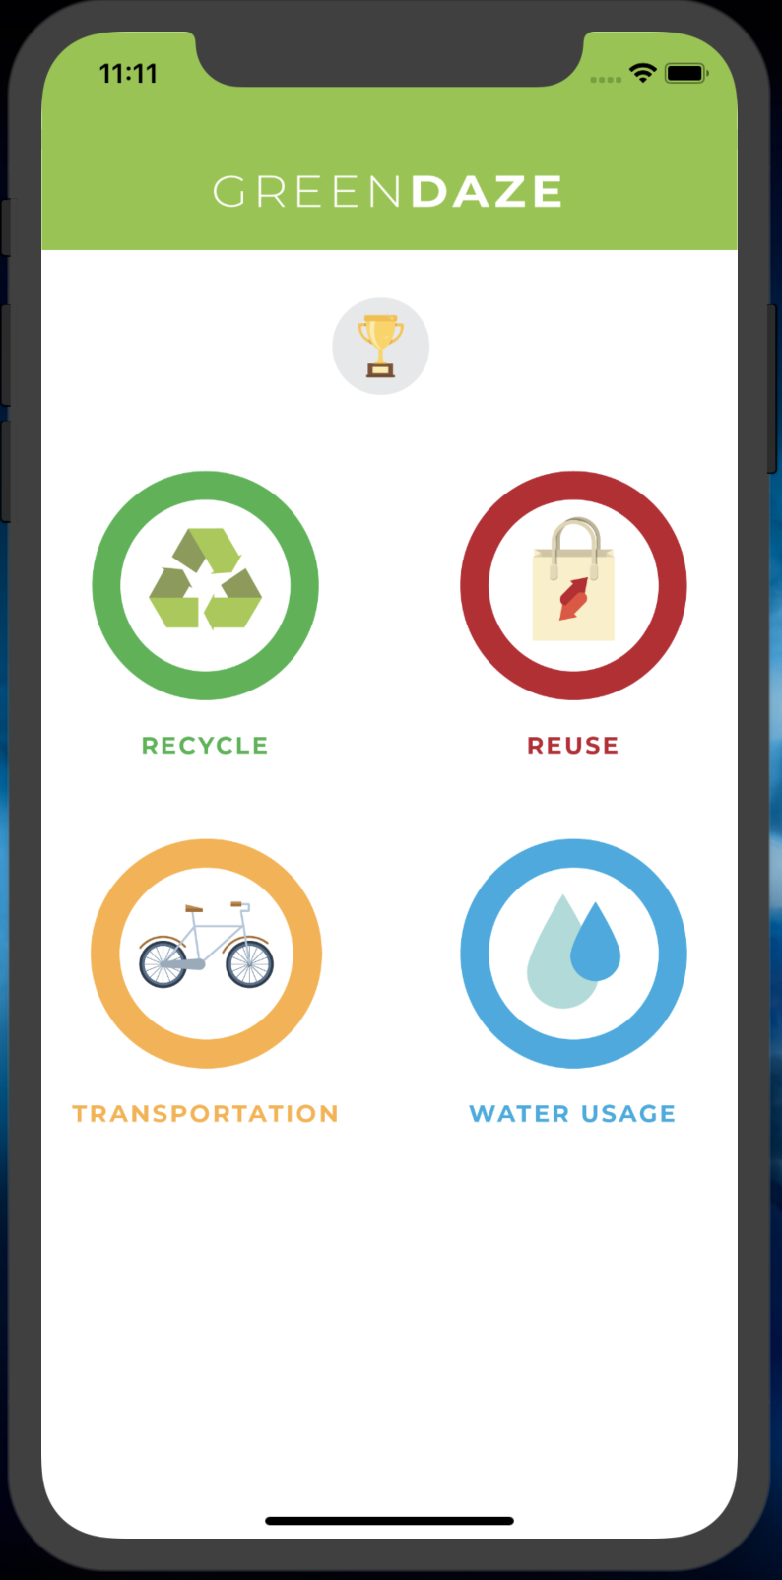

(Screen shots: a screen shot for each view of the app)

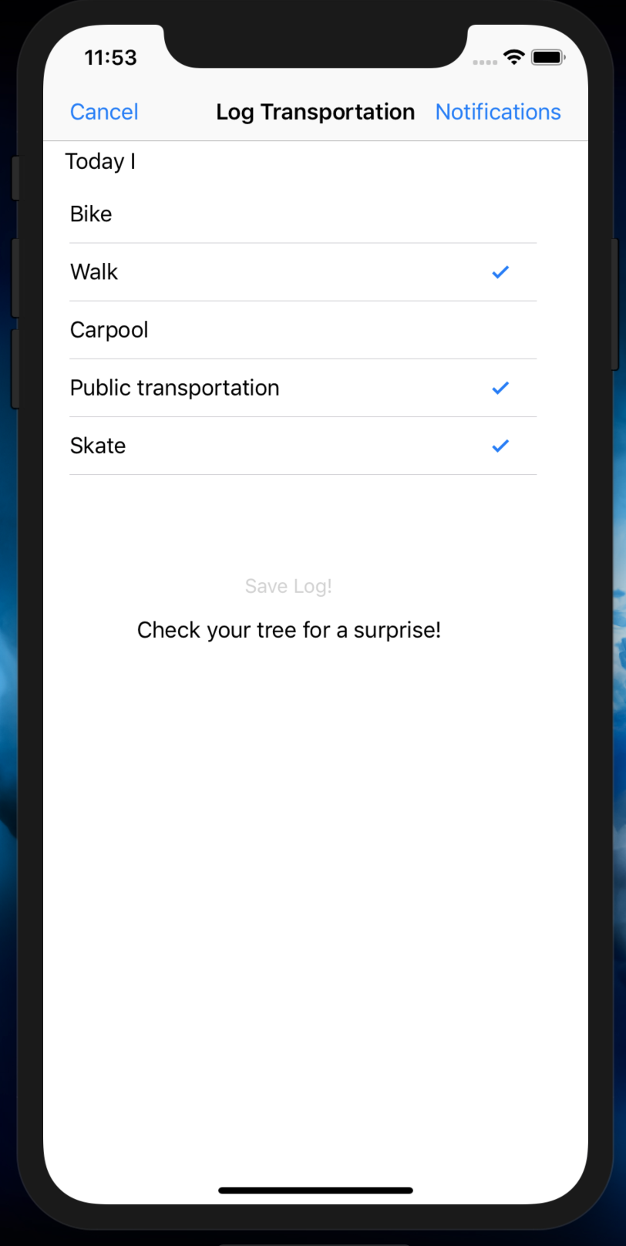

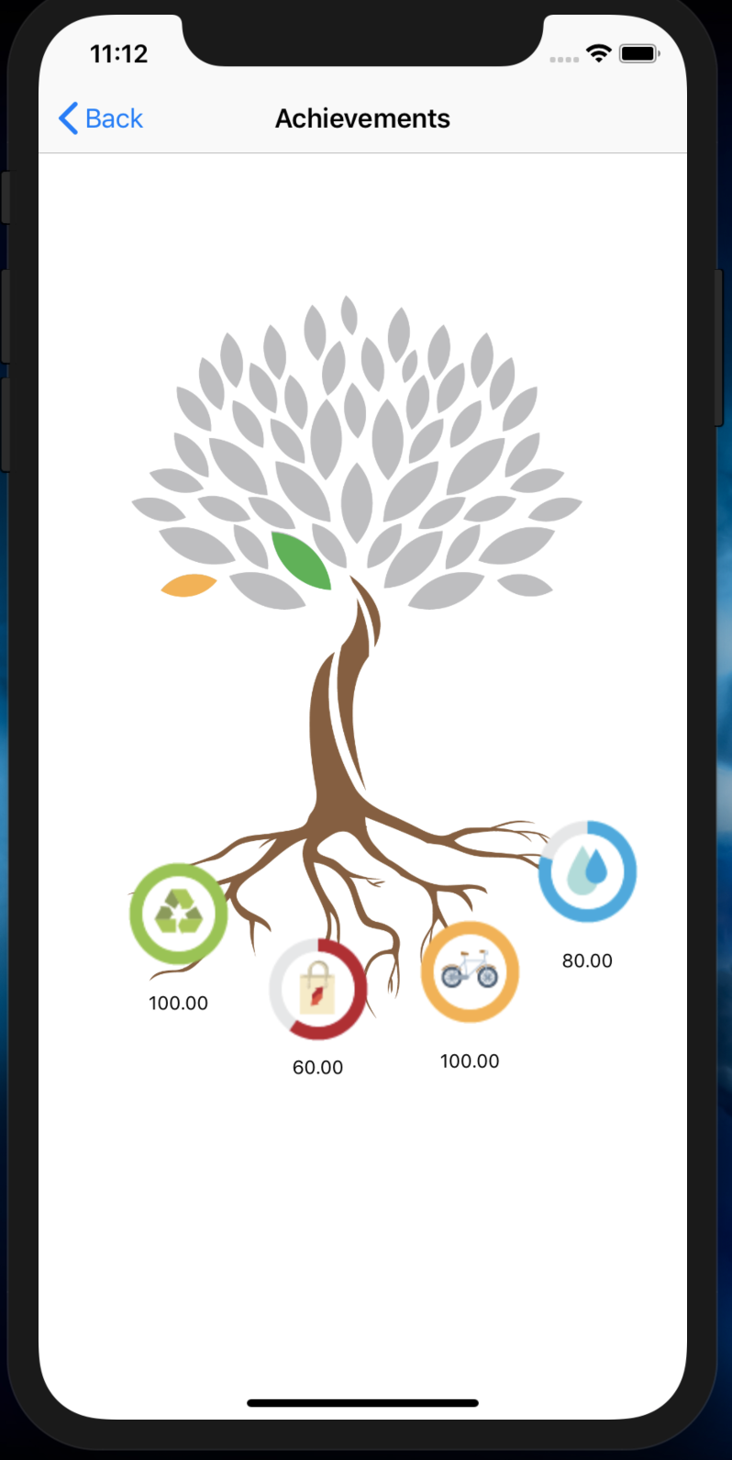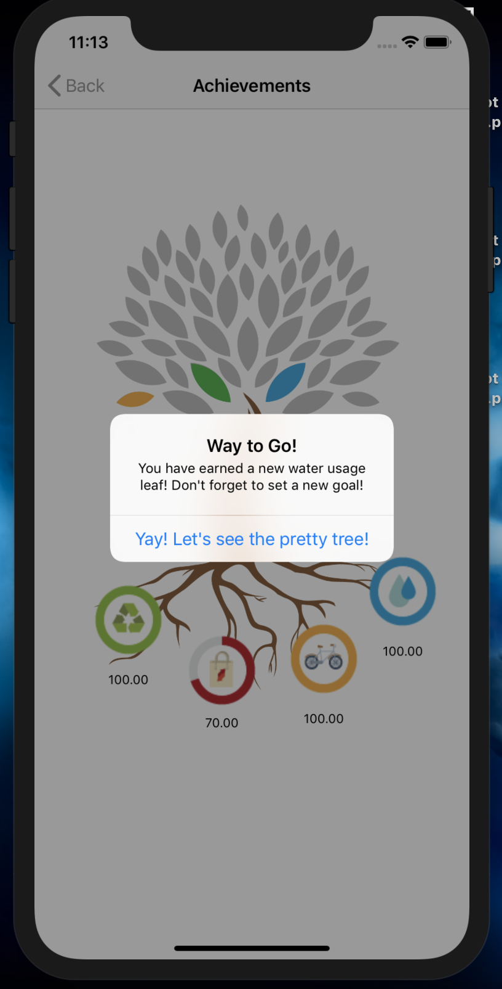

**Logic flow/storyboard** (describe the logic path that the user is expected to follow)

For this project, we created a Multi-page view app that requires Navigation controller screens, segues and the buttons on each page take you to their respective settings so the user can create notifications and alerts as they wish.

This image to the left here shows our logic paths where we created the navigation from screen to screen. When the user creates a notification alert, it takes them back to the selection screen where they make their behavior change and as they save their log, it takes them back to the home screen.

**Features** (describe which features that you implement to expand the scope of your app from the apps you’ve learned in the class)

The home screen contains four buttons (Recycle, Reuse, Transportation, and Water Usage). Each button segues to pages where the user can check off items/tasks they complete using radial buttons. The user can also set goals and notifications.

The home screen has fifth button that leads to the Achievements page. This page shows the user’s progress and achievements. It contains a tree with grayscale leaves which appear in their full color when the user completes actions. Each leaf represents the completion of a goal in a specified category.

At the roots of the tree, there are four progress trackers that show how far the user is to reaching their goal within each category (Recycle, Reuse, Transportation, and Water Usage).

Here we can see the ALERT that comes up when a user completes an achievement and is awarded a leaf on the tree.

This is the first screen of the app that you will see.

It shows you:

* Achievement icon
* Progress Bar
* the 4 places you can go to work with the app:
  + Recycle
  + Reuse
  + Transportation
  + Water Usage

This is the first button to click on is the RECYCLE button.

Here you can make selections of what you want to log as your Recycling activity.

This page will allow the user to create NOTIFICATIONS of when they would like to be reminded to Log their activity.

The user can then SAVE the log to be able to track their progress.

All other buttons have the same Logging options as well as creating Notifications and saving the log.

When you click on NOTIFICATION, the app will take you to the Recycle SETTINGS.

Here you can select to track this goal.

The user can select how many times a day, week or month they want to track the goal.

Also, they can set an alert to remind them to track the goal each day of the week at a time of the users choice.

When you go back to the home page and select the ACHIEVEMENTS icon, it will take you to the Achievements Page.

This page shows your tracked progress as a visual on the Tree. Each leaf will change color as you complete your set goals for the time you selected.

The bottom buttons will show you the percentage of your progress and if you click them, they will take you back to the page where you set those goals if you want to update your selections.

**Implementation Issues**

(any difficulties that you encounter in the implementation and your solutions to the problem.)

It was hard to implement the right progress bar. We didn’t want to create 4 progress bars on the top, next to the achievements.

This was a tough one to create but since we had already implemented the images of the progress under the tree, we decided to take it out altogether so we would have everything functioning properly.

**Demonstration**